# 



## An Introduction to React.js – The Modern JavaScript Library

## History & Creators

* React.js was created by **Jordan Walke** at Facebook in **2013** to enhance the scalability of Facebook's user interface.
* Recognizing the need for more efficient solutions, Walke developed React to simplify the process of building dynamic and interactive UIs.
* Its significance lies in its component-based architecture, which allows developers to reuse code and streamline the development process.
* Since its inception, React has transformed web development practices and gained widespread adoption among major companies worldwide.

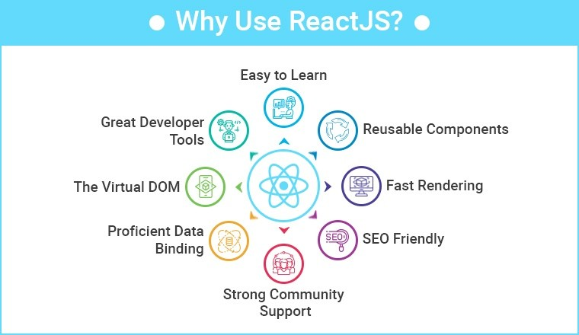

## 

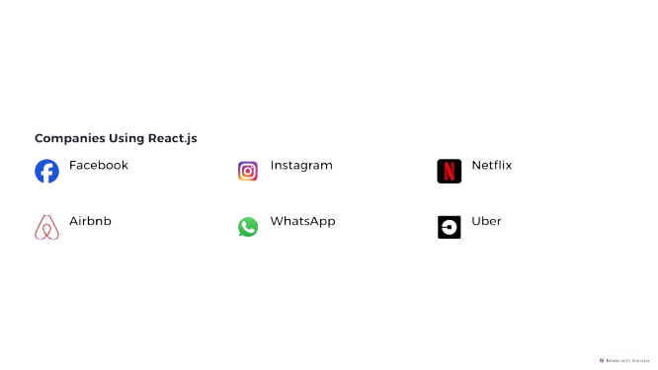

## 



## Key Features of React.js

### Core Features

React.js is built around several key features that enhance its usability and efficiency:

* **Components**: The building blocks of any React application, allowing reuse and encapsulation of logic.
* **JSX (JavaScript XML)**: A syntax extension enabling developers to write HTML-like code within JavaScript, improving readability.

### State Management with useState Hook

The useState Hook simplifies state management in functional components. Here's a quick example:

const [count, setCount] = useState(0);

### Virtual DOM vs. Real DOM

React employs a Virtual DOM for efficient updates, preventing unnecessary re-renders. Unlike the Real DOM, which directly manipulates the browser's page structure, the Virtual DOM minimizes changes, significantly enhancing performance.

